Solar Harvest

Technical Specifications:

Game created by using C#.

* Requires a 64-bit processor and operating system
* OS: Windows 7 (or Higher)
* Processor: Dual core from Intel or AMD at 2.0 GHz
* Memory: 2 GB RAM
* Graphics: Video card with at least 512MB
* Storage: 50 MB available space

User Guide

When entering the game, you will see the menu where you will have to press Start to first select your map (Uhotora, Ealinet, Mepola, and Niottugus)

and a character (Aiden & Ethan, Anwir, Peteplank, and Yamato).

You cannot Start a game unless you choose the Map & Character.

* when you press buttons in the Map Menu, your selections will become red

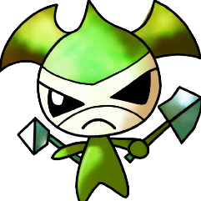There are 4 bosses:

Adbaldar



Atlantes

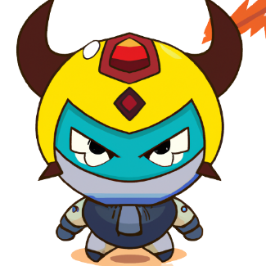

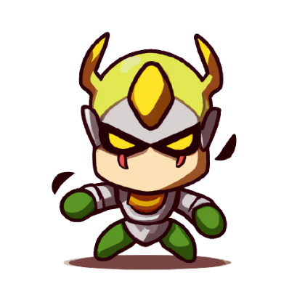Elminster

Radagast

After selecting your map & character, you will start on an adventure on that map.

* on the Left Up – side corner is your HP.
* on the Right Up – side corner is your enemy’s HP.
* on the bottom of the window there will be 3 buttons: [ATTACK]; [DEFENSE]; [ABILITY]

[ATTACK] – Your character will do a basic attack, damaging the enemy

[DEFENSE] – Your character guards against incoming damage, taking only 50% of it

[ABILITY] – Your character uses their special ability against the enemy

* 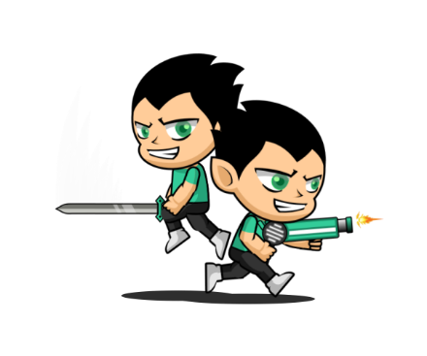Aiden & Ethan = removes enemy’s defense and deals double damage, but you take half of the normal damage

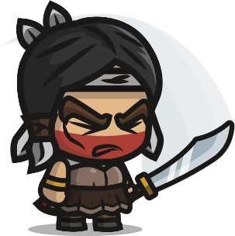

* Anwir = heals 10 HP, can overheal (get more than 100 HP)
* Peteplank = will put up defense and attack at the same time, the cost for this ability is to lose 5 HP



* Yamato = attacks 3 times consecutively, but for each attack he receives half the damage
* the action buttons will become available when your turn starts and will become unavailable during the opponent’s turn.
* under each Character is the current action that the Character has taken
* after finishing the game (meaning that the Boss or your Character gets killed) only the Menu button will be available
* buttons are transparent and they become solid when hovering with the mouse over them
* on the bottom right corner you will have the Menu which gets you back to the Main Screen where you can exit the game or select another map therefore canceling the current adventure.
* implemented sounds for attack, defense and special ability and background music.
* Project Schedule

